# Task 5: User Guide for Pitches

# Create Pitch:

1. Click button **‘Create’.**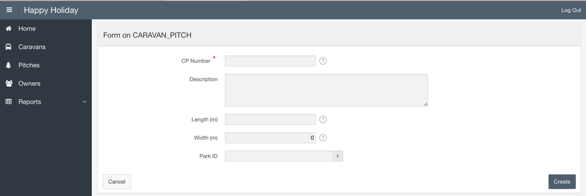
2. Insert Data Into Fields ( * - obligatory),consider following rules:
   1. CP Number must be UNIQUE.
   2. For Length and Width max value – 15 (m).
   3. You can’t insert Width without Length. First insert Length, then Width.
3. Select Park ID and click **‘Create’**.

**Update:**

1. Click on any **‘Pitch #’.**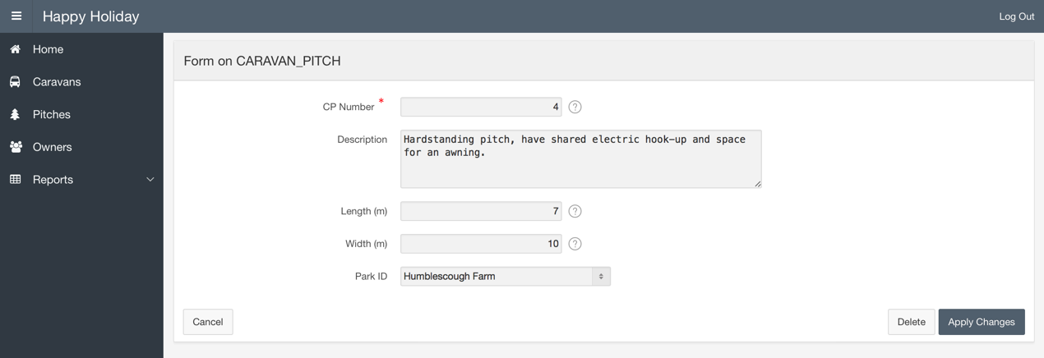
2. Change any fields you want, consider following rules:
   1. CP Number must be UNIQUE and can’t be NULL.
   2. For Length and Width max value – 15 (m).
   3. You can’t insert Width without Length. Length must have a value.
3. Click ‘Apply Changes’.